For the last discussion board of the term, I wanted to explore and explain the acronyms: SQL, DDL, DML, DQL, and DCL. With each acronym, I wanted give some insight on what its primary use is within each of the respected areas. Afterwards, I will be providing some advantages and disadvantages to using SQL.

SQL: Structured Query Language

It is a programming language that is typically used in relational database or data stream management systems. (Techopedia, 2020) When it comes to SQL, it can be categorized into four different categories depending on the command you are using within the language. Below is an image showing how SQL commands are split into the different areas and the commands that are within each of them.

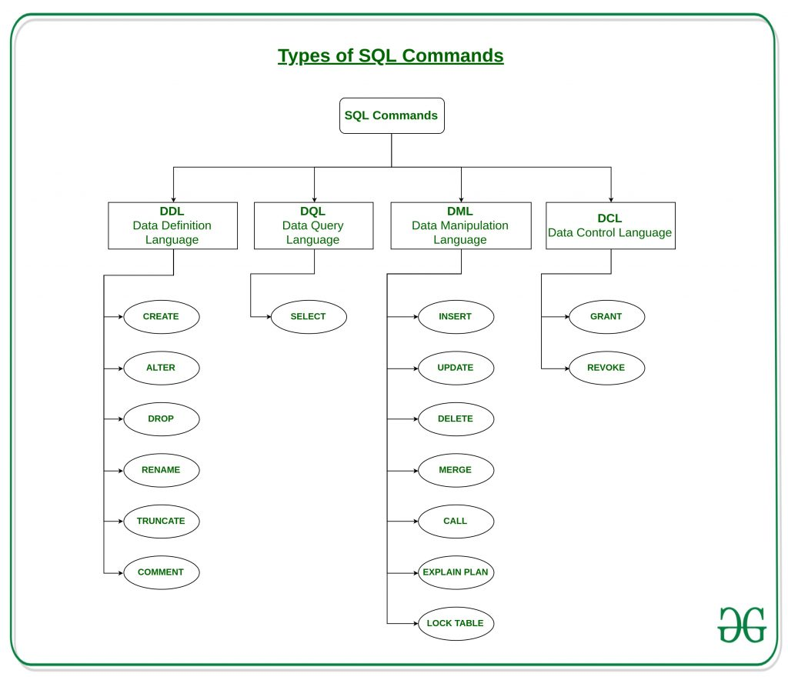

Types of SQL Commands

DDL: Data Definition Language

It deals with descriptions of the database schema and is used to create and modify the structure of database objects in the database. (Varshni, 2019)

DQL: Data Query Language

DQL statements are used for performing queries on the data within schema objects. (Varshni, 2019)

DML: Data Manipulation Language

The aspect that deals with manipulation of data present in the database belong to DML. (Varshni, 2019)

DCL: Data Control Language

In this area, it mainly deals with the right, permissions, and other controls of the database system. (Varshni, 2019)

With seeing all of the different aspects that are involved within this language, it is important to understand that it is not a perfect language and will have its parts that are beneficial and non-beneficial to the process. Looking at the advantages of it, the first being that it allows for a faster query process in which large amounts of data is retrieved quickly and efficiently. In my opinion, a strong advantage is that it does not require a strong coding background and that it is easy to learn and understand allowing for many people to utilize the language. However, with SQL, it can be known to have a difficult interface to work with deterring people from using it all together. At the same time, many companies will give out certain permissions to data on different levels which would not allow someone to have complete access to the database. Even though this is not a direct connection to the programming language, it shows more limitations one could face when using the language in different settings.

In the end, SQL has provided several opportunities for people to access and manipulate information in their respective databases. In the beginning, I had only seen SQL as one entity, but after seeing this visual and the different parts that are included within the programming language; it was interesting to see how each aspect contributes to the overall structure of it.

References:

Simran, J. (2020, April 10). Advantages and Disadvantages of SQL. Retrieved May 18, 2020, from <https://www.geeksforgeeks.org/advantages-and-disadvantages-of-sql/>

Techopedia. (2020, March 27). What is Structured Query Language (SQL)? - Definition from Techopedia. Retrieved May 18, 2020, from <https://www.techopedia.com/definition/1245/structured-query-language-sql>

Varshni, D. (2019, August 26). SQL: DDL, DQL, DML, DCL and TCL Commands. Retrieved May 18, 2020, from <https://www.geeksforgeeks.org/sql-ddl-dql-dml-dcl-tcl-commands/>